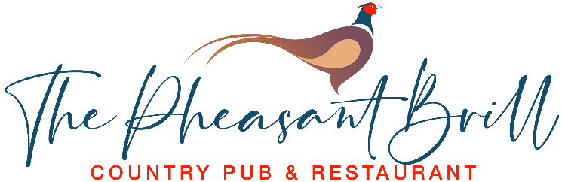
Starters
Soup of the Day £8
“Avocado Edda” - Grilled Avocado, Prawns, Mushrooms & Grilled Mozzarella £8.50 GF
Chicken Caesar Salad £8.50 GF
Mozzarella & Tomato Bruschetta £8.50 V
Classic Prawn Cocktail £9 GF

Pub Favourites
South Indian Garlic Chilli Chicken Curry, Rice,
Flat Bread & Salad £16.50 GF DF
Bangers & Mash, Onion Rings & Gravy £16.50
7oz Boarstall Belted Galloway Beef Burger, Bacon, Cheese, Burger Sauce & Fries £16
Chicken Caesar Salad Main Course £16.50 GF

From the Sea
Beer Battered Haddock & Chips, Garden Peas,
Tartar Sauce £16.50 GF DF
Prawn Puri – Curried Prawns, Flat Bread &
Spicy Onion Salad £18 GF DF
“Posh Scampi” – Battered Tiger Prawns, Fries & Sweet Chilli Sauce £18 GF
Pasta
Truffle & Burrata Ravioli, Spinach, Mushrooms, Cream & Peas £18 V
Smoked Salmon Spaghettini, Garlic, White Wine, Cream & Garden Peas £18

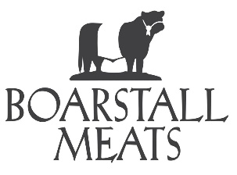
Boarstall Meats Belted Galloway 40 Day Aged Steak
8oz Fillet £30 GF DF
Served with Field Mushrooms, Grilled Tomato, Onion Rings, Fries, Salad & Peppercorn Sauce

Vegetarian
Three Cheese Omelette, Salad & Fries £16 V GF
Vegetable Curry, Rice & Flat Bread £16.50 V DF VG

Side Orders
French Fries ● Hand Cooked Chips ● Mixed Veg Onion Rings GF ● Mixed Salad
£3.75 per side order

Desserts
Crumble of the Day & Custard £8
English Berries Eton Mess £8 GF
New York Style baked Vanilla Cheese Cake, Fruit Compote £8
Chocolate & Caramel Fudge Cake, Vanilla Ice Cream £8
Affogato – Vanilla Ice Cream topped with a Double Espresso £5 GF
Ice Creams £2 per Scoop
Chocolate ● Vanilla ● Strawberry

